In this chapter, we have come to a key intersection in Scripture. Zechariah is speaking, directed by the Lord to multitask: he speaks to current history – Judah in Jerusalem 2500 years ago; and at the same time, he hurls out the prophecy to its fulfillment… recognizable as if the prophet was telling it to us today.
Zechariah wrote around 500bc, when roughly 10% of the House of Judah in captivity returned to Jerusalem, to rebuild the desolate region in advance of Messiah’s first coming. Most of Judah had grown comfortable in their new home of Babylon… where they lived for the next several centuries, having rejected the Torah of Moses; and there, steeped in manmade traditions, they created 4 universities, institutes of higher learning; and in NT parlance we would say for all their smarts … they lost their first love – Revelation 3.
Matthew Henry wrote that God’s prophet, who in the previous chapters, was an ambassador sent to promise peace, is here a herald sent to declare war. In dark and figurative expressions, faithless Judah and Jerusalem are in focus. When the flock was brought to Jerusalem, it meant it was ready for sacrifice.
¹ Open your doors, O Lebanon, that the fire may devour your cedars! / Judah in Jerusalem would not open their doors to let the King of glory in; we read, He came to His own, and His own did not receive Him – John 1; but now, they must open their doors to let their ruin in.
From the highest, most stately, to the lowest most insignificant… a firestorm will one day consume the land, perhaps, the whole earth.
² Wail, O Cypress, for the cedar has fallen;
for the mighty trees are ruined!
Wail, oaks of Bashan, for the thick forest has fallen! / and people in the 21st century might ask, what does this mean? Well, we know the prophet is not critical, condemning the Lord God’s creation; there is not one thing wrong… with any of His majestic forests.
We are not having a lesson on dendrology, or botany or the science of any woody perennial plant having an elongated main stem… with few or no low branches on its lower part.
We might not know what it means to rebuild the temple; but Zechariah and those he was talking to all knew where the finest wood came from; and they knew what it took to snugly fit each piece into the sacred complex.
So let’s remove the references to the woody plants, and hear what the Lord is saying to His people:
Wail___, for they have fallen; for the mighty ___ are ruined!
Wail, for it has fallen! / those who thought they were chosen, are discovering they are not.
Hear it again:
Wail, lands to the west, for they have fallen; for the mighty are destroyed!
Wail, lands to the east, for they have been cut down!
not confusing, is it? Tell it to those in the west and those in the east. And should some still say: I don’t understand… suddenly the Lord spells it out to those in Judah… to those particularly in Jerusalem, who sang for 500 years – The Lord is my shepherd, I have no needs; He leads me beside still waters – Psalm 23; the Lord is still the Good Shepherd.
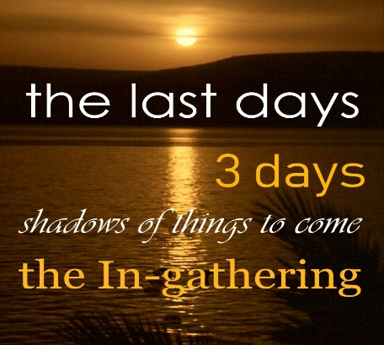
And Zechariah says:
³ Hear the wailing of the false shepherds; for their glory is ruined! the roaring sound of young lions; for their lair of the Jordan is ruined!
⁴ Thus says the Lord my God;
shepherd / lead, feed, guide… the flock doomed to slaughter / 1000 years earlier, Moses, also a shepherd, warned them of the choice: to be a blessing or a curse; clearly… their fake leaders chose to be a curse, they would tickle their ears, and then feed them junk food; not the good word of God; leaving them to starve; as they led them in confusion.
Through Zechariah, the Lord God speaks to those gathering in Jerusalem. And is that why they are coming? To be doomed? Whenever the flock was brought to Jerusalem, it meant it was ready for sacrifice; is that why so many in recent years are returning to the land of Judah and Jerusalem? Is it why so many are pushing to get into America? Is it the reason so many hope to get into the UK? Do they not know the prophecies coming to these 3 faithless shepherds? The last verse of Zechariah some translated: there will not be found a traitor in the household of the Lord in that day;
Thus says the Lord my God
shepherd the flock doomed to slaughter / under the tyranny of their own govt, the leaders of Judah in Jerusalem became perfect tyrants, engrossed in wealth; devouring properties, fleecing the flock instead of feeding it. Is that old history or current events? No different than the UK and the USA. Was there enemy infiltration going on in these three world centers of the Lord’s blessing? Yes the 4th beast. smashing and destroying until the whole world it broken.
Zechariah told them, A time will come when 10 men from all the nations, multiplied many times, would grab the sleeve of a Jew, saying, let us go with you, for we hear God is with you. And you wonder when will that happen, when what you hear from the mouth of the orthodox in Judah caught in their puny worldview, what the prophet told them -- that the nations were joyously on their way was furthest on their mind.
Those who listened to the prophets knew there was a price on the head of God’s people; yet the Lord insists; feed His sheep – the young ones, the older ones; the sheep belong to Him.
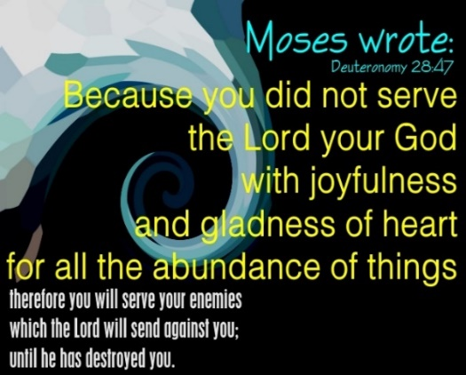
⁵ Those who buy them, slaughter them, and go unpunished / think about it: a two-tiered society where people purchase people. Is that why so many children go missing every year?
Those who secretly abuse and murder children? Lawless criminal-elites, and laws for everybody else which sounds like today:
and those who sell them / who sell children, who sell aborted baby parts; and treat them like cattle that can be the game of the wealthiest sociopaths with seared conscience; heartless and merciless; who say,
Blessed be the Lord, I am rich / those who merchandise in the souls of men – even in the 21st century; they might sound spiritual, but they aren’t: and their own shepherds have no pity for them / their own leaders, there in Jerusalem who could have helped Judah become a blessing to the world, instead embezzled God’s gifts and sold out the flock, and is that old history or current events? Because it happens in London and DC, too.
And now we pause and hear another brother of Judah… one in our 21st century; who watches current events and struggles to make sense amid his desire to do what is right in the eyes of the Lord. The stakes are so high, so we must get this correct as we hear what the Lord told Zechariah… and keep it tied to: Thus says the Lord my God:
Steven Ben Nun of Israeli News live… who gave 3 summaries on collusion as it touches on Jerusalem.

Plan Follows Vatican Agreement | War On 7 Countries In 5 Years | Betrayed From Within
also look up: the Ringworm Children | the Duplessis Orphans | the unfettered abuse of children in any country will not go unanswered by the Lord of hosts who will pick the time and place.
⁶ For I will no longer have pity on the inhabitants of the earth, says the Lord / in chapter 7, Zechariah warned them; if they did not dispense true justice; if they did not respond to the cry of the widow, orphan, foreigner or poor; then, when they cry, He will not hear them; suddenly when the Lord plays their game, it’s like somebody will lose big time; and it won’t be the Lord.

Behold, I will cause them to fall into the hand of his neighbor, and each into the hand of his king: / the inhabitants of the earth… starting with some faithless royal jackass of Judah, coming from Jerusalem will be a concussion of violence that resonates throughout the world – it seems they didn’t believe the Lord who said: it’s not by might, not by power, but by My Spirit, and are some of Judah, traitors who still have no king but caesar? Daniel was told that the 4th govt – which we know is roman… will be hard as iron smashing and destroying… until the whole world is broken till the Rock of ages comes and knocks over that damnable beast -- Daniel 2.
So starting with some misstep of some fool in Judah, or Jerusalem:
they will crush the earth… and I will deliver none of them. WOW! The previous chapter spoke of the troubling times, and the Lord says…
⁷ So, I became the Shepherd of the flock doomed to be slaughtered,
even you, O poor of the flock / the Lord Himself came to do the job – Ezekiel 34.
And I took two staves, one I named Beauty / Favor; Judah was to be His Praise; not His censure, the other I named Bands / United, Israel led by Ephraim and Manasseh – 2 brothers were to be a united effort bringing blessing to the whole world; but their degenerate traitors became the world’s curse;
so I shepherded the doomed flock / The Lord tended and guided His people; from His heavenly advantage He always guides His people, some will rise to everlasting life; some will rise to everlasting shame and contempt. But now the In-gathering is near, when Messiah comes.
⁸ In one month, I destroyed three shepherds / WOW! Is it correct to say 3 persons of Judah, Ephraim and Manasseh were destroyed? Or are we learning about the peoples of Judah, Ephraim and Manasseh? Were they all sell outs to caesar? Is this old history? Or as I suspect, prophecy yet to be fulfilled?
My soul detested them, and their soul abhorred Me / so the feelings were mutual.
⁹ So, I said, I will not be your shepherd / which means: they lose! Again, is this Judah, of Jerusalem, Ephraim the once great commonwealth, and Manasseh – the once great nation… are they all losers?! YES!
What is to die, let it die,
what is to be destroyed, let it be destroyed.
And let those who remain destroy one another.
¹⁰ And I took my staff Beauty, and broke it, annulling the covenant that I made with all the peoples / like the days of Noah; and now He prepares for a time of trouble such as never was.
¹¹ And that day, it was annulled / when He canceled His covenant; and if we were there would we see the rainbow disappear? Certainly, His restraint to destroy all evil on the earth disappeared – having for long enough let the tares grow among the wheat Yet, He has the attention of the afflicted, the poor of the flock, will keep their eyes on the One who matters most;
the poor in spirit… who were watching Me, knew that it was the word of the Lord / they were on His side, this word made sense to them, too.
¹² And I said to them, If it seems good to you, give Me my wages / not just the ones watching Him, but to all the peoples, all who were supposed to have been His Praise, and all those who were to be United in Him, led and governed by Him; He said: since you are weary of me, go ahead, pay me off and discharge me;
but if not, never mind.
And they weighed out for My wages thirty pieces of silver / the thieving traitors like Judas gave him the paltry price of a slave.
¹³ Then the Lord said to me / prophet Zechariah, Throw it to the potter – that magnificent price which I was valued by them.
So, I took the thirty pieces of silver and threw them to the potter in the House of the Lord / these verses were fulfilled by the traitor who betrayed Messiah.
¹⁴ Then I broke My other staff Bands / United, annulling the brotherhood between Judah and Israel / the devout familial traits of brotherhood were cancelled; as the fratricidal discord of factions raged long ago… their histories tell us this is what happened as they went their own way to be ridden by a whore; and is this old history or current events?
¹⁵ And the Lord said to me,
take again the equipment of a foolish shepherd / and it makes you wonder what did Zechariah take, what are the tools of a fool unfit for the job of shepherding? Maybe, he took a Revised Standard Bible -- 666th revision? whittled and pruned to the size of a gnostic. We know it’s a fool who says there is no God – Psalm14, 53; definitely, the word of God won’t be found in his toolbox. Perhaps he took a stylish shepherd’s coat, a $$bag and a staff… to fit the Hollywood impression; since if the wolf comes, we can be sure, being a hireling, he’ll run.
¹⁶ For, lo, I will raise up a shepherd in the earth / and is this the last worthless roman leader that Daniel told us about? Or will it be a worthless leader from Judah? Have you noticed how roman and Jewish orthodox are so similar in their dismissal of the word, while elevating their hocus pocus?
who does not care for those being destroyed,
who will not seek the young who are scattered,
or heal the maimed, or nourish those lagging behind:
but he will eat the flesh of the fat, and tear off even their hoofs / not a surprise; that is something the portly sanctimonious as well as their company, the royal pedovoures do very well.
¹⁷ Woe to the worthless shepherd who abandons the flock! May the sword strike his arm, and his right eye! Let his arm be wholly withered, and his right eye be utterly blinded.

Thankfully, many of Judah are busy waking those who will hear in and around Jerusalem; and others in the UK and USA. Check out our cousins who know: it’s not by might, not by power, but by My Spirit says the Lord:
Check out our messianic brothers in the Lord: great sons of Judah
Dr James Tour a world leading expert on nanotechnology Dr James Tour: his testimony
Steve Olin’s testimony: a Jewish billionaire Jesus Christ and Nanotechnology
ONE FOR ISRAEL | LEON MAZIN - TIKKUN | MESSIAH OF ISRAEL | STEVEN BEN NUN | BEHOLD ISRAEL
This is My Father’s World | Salvation is Your Name | JESUS, it is YOU
Every Praise
O Come Let Us Adore Him

