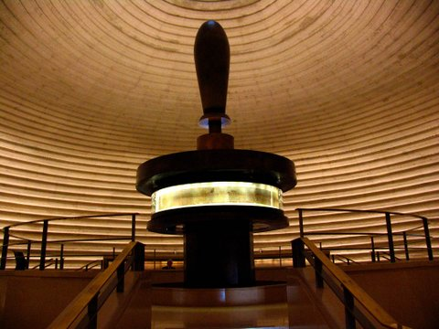
¹And it happened in the days of Ahaz the son of Jotham, the son of Uzziah, king of Judah / so we are learning about the great grandson of Uzziah – the 3rd and fading generation after the great zenith of the kingdom of Judah,
that Rezin the king of Syria / an abbreviation for Assyria, and Pekah the son of Remaliah, king of Israel went up to Jerusalem to war against it, but could not prevail against it. / Israel was given all the promises first to Abraham and Isaac. So, why are they in alliance with neighbors against his brother? We’re learning about 2 clueless fools in seats of power,
² And it was told the house of David, saying, Syria is confederate / allied… with Ephraim, and his heart was moved, and the heart of his people, as the trees of the wood are moved with the wind / Ahaz along with his people of Judah were as trees fiercely tossed and shaken and nearly uprooted by the storm winds blowing; obviously there is not much faith and confidence in the Lord God going on.
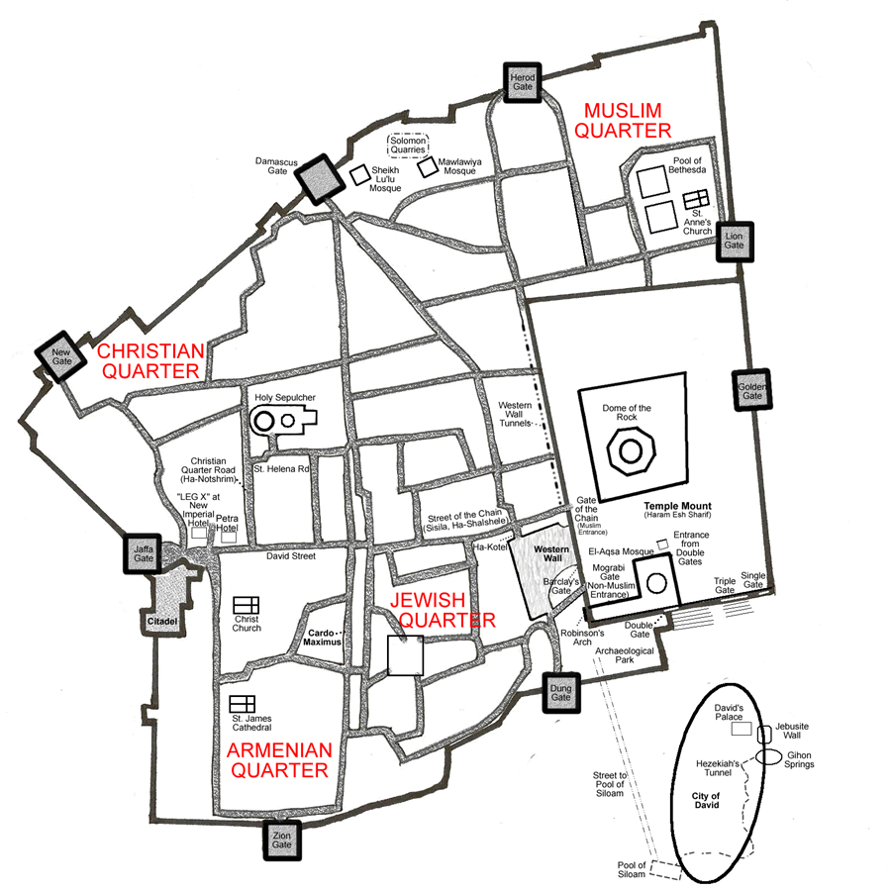
³ Then the Lord said to Isaiah, Go now to meet Ahaz you and your son Shear-jashub / his son’s name means: a remnant will return; the order given to Isaiah to go and encourage Ahaz in his distress; not for his own sake (he deserved to hear nothing from God but words of terror), but solely because he was of the lineage of David,
at the end of the conduit of the upper pool in the highway of the fuller's field / so Isaiah is instructed to take his son and meet Ahaz at the only place in Jerusalem where the vital water supply can be cut off from the enemy while being secured for the city; the only underground source of water -- a place still known today, where the temple of Solomon was completely dismantled stone by stone just as Jesus foretold.
⁴ And say to him, Take heed, and be quiet; do not fear, nor be cowardly for the two tails of these smoking firebrands, for the fierce anger of Rezin with Syria, and what’s his name the son of Remaliah. / clearly, calm down; don’t be fearful of these smoldering twigs; the Lord wants Ahaz to shut up,
⁵ Because Syria, Ephraim, and what’s his name the son of Remaliah, have taken evil counsel against you, saying,
⁶ Let us go up against Judah, and vex it / let us annoy Jerusalem -- the favorite pastime of trouble makers against the people of God in every generation (even today) they’re not blazing; so, they’ll soon fizzle out; Yet their boasts continue…
and let us make a breach in it for us, and set a king in the midst of it, even the son of Tabeal / these deluded fools have all their plans; they think they will divide the territory; it’s the typical speech of the open border hoarders and their followers; who chose some freakish lowlife; an obscure political loser of the day -- most likely a compromiser fit to appease both nutty sides:
⁷ Thus says the Lord God, It will not stand, nor will it come to pass / Ahaz, it ain’t gonna happen. Whatever stands against God doesn’t stand too long.
⁸ For the head of Syria is Damascus, and the head of Damascus is Rezin; and within sixty-five years Ephraim will be broken, that it is no longer a people / in the neighborhood, they will be resettled in a buffer zone between Assyria and Babylon; thought lost to history, but not to God; because the Lord God already has plans for Ephraim who was given all the promises to Abraham, Isaac and Jacob… exceptional promises, unconditional, nationalistic promises… ordained by God. God intends the descendants of Ephraim will accomplish them where He sends them, till the time of the Gentiles is fulfilled. They were not to be heaped on the dunghill of history, they have work to do till the very end, when Messiah comes in power and great glory.
⁹ And the head of Ephraim is Samaria, and the head of Samaria is Remaliah's son / the Lord knows who is who; and who is the biggest agitator and where they hide.
If you will not believe, surely you will not be established / God patiently works individually with all people, even the scummiest of the earth. He gives them opportunity to be established in the promises of God, and not be tossed around by every wind. But remember, the demons at least believe, and they tremble. Mankind needs to move beyond belief; without faith, it is impossible to please God. Notice, Isaiah didn’t say much; because God was ready to drill this man’s hard head.
¹⁰ Then the Lord spoke again to Ahaz, saying, ¹¹ Ask for yourself, a sign from the Lord your God; and make it as deep as hell or as high as heaven / so God speaks a second time directly to him. Wow! How many times does the Lord have to speak? God knew Ahaz discredited the prophet’s voice, so He directly offers Ahaz the widest limits within him to choose some miracle, any miracle to affirm God spoke to him.
¹² But Ahaz said, I will not ask, nor will I tempt the Lord / a secret hostility to God is often disguised with the specious colors of respect to Him; and those who are resolved that they will not trust God, yet pretend that they will not tempt Him – Matthew Henry.
¹³ And he said, you listen now, O house of David, is it too small a thing for you to weary men, but will you weary my God also? / it is as if Isaiah the prophet jumps into the conversation; did Isaiah interrupt the Lord? As if Isaiah comes out ready to punch for God’s honor and glory; Isaiah was probably thinking by the oppression and tyranny of Ahaz, he was already odious and burdensome to mankind,
¹⁴ Therefore the Lord himself will give you a sign; and it wasn’t a finger, like maybe Isaiah and definitely most of us would give, because God is patient and long suffering,
Behold, a virgin will conceive, and bear a son, and will call his name Immanuel / the greatest sign of God… reaching to the height and depth of all creation. The Messiah would be introduced on a glorious errand, wrapped up in His glorious name meaning: God with us.
¹⁵ Butter and honey he will eat, that he knows to refuse evil, and choose good.
¹⁶ For before the child knows to refuse evil, and choose good, the land that you abhor will be abandoned by both her kings / in just a few short years this would happen.
¹⁷ The Lord will bring upon you and your people, and upon your father’s house, days that have not come since the day Ephraim departed from Judah; even the king of Assyria / when the king of Assyria comes to town it will be like nothing they had experienced.
¹⁸ And when it happens, the Lord will whistle for the annoying fly in the most remote part of the rivers of Egypt, and for the irritating bee in the land of Assyria / speaking of two august political centers, pesky enemies as despicable as a fly or a bee... is not a compliment. Notice the Lord states: it ain’t a roaring lion coming; however at His prompting, the entire country would be taken.
¹⁹ And they will come, and settle in the desolate valleys, in the crevasses of the rocks, and upon all thorns, and upon all bushes;
²⁰ On the same day, the Lord will shave with a razor that is hired from beyond the river -- namely, the hired king of Assyria, from the head to the hair of the feet / and is this just figurative? No! The invaders will find it easy to seize the country left by those fleeing; as the hired barber of Assyria will give them a clean shave of the entire country from head to toe: literally the last time Ephraim, his brother Manasseh and all the northern tribes were in Samaria, they got trimmed and went away humiliated, and where they were going to naked, they never looked the same.
and will also take the beard / Isaiah says, when the barber is finished, the house of Israel where they resettle at the Caucasus mountains, will not look like those bearded folks in the middle east. When their ruin comes, it will be total. This is what Isaiah also noticed about the great nation
²¹ And it will happen in that day, that a man will feed a calf, and two sheep / where they previously had flocks and herds; the cattle will be decimated;
²² And it will happen, for the abundance of milk that they will give… he will eat butter: for butter and honey will everyone eat that is left in the land / but realize, there will be more than an abundance of milk, and butter and honey… because there will be so few left in the land.
²³ And it will happen in that day, that every place where there once was a thousand vines for a thousand pieces of silver, will become briers and thorns / this speaks to the yearly commerce and exchange, the renting and planting of once prosperous landlords and tenants in affluent times; now, the result of failed economic policies, ending with swapping tools of cultivation for implements of war… which leads to the destruction of the nation.
²⁴ With missiles and with bows people will come there; as a result, all the land will become briers and thorns.
²⁵ And on all hills dug by wild boars, there will not come fear of briers and thorns, but it will be a place for pasturing oxen, and for cows and sheep to trample / wild animals aren’t bothered by prickly briers and thorns; due to the absence and neglect of land left uncultivated, there was nobody to bother all the lumbering oxen, cows and sheep; with cats and dogs, and all the gophers too, they all enjoy freely roaming the vacated promised land.
all because brothers did not know how to be brotherly to one another… and cousins did not know how to be good neighbors to each other. Tragically, the Lord God who first created all things good… He was lost in the mix, leaving only a disastrous mess made by mankind… still evident today in our genius 21st century.

